**Biol 1610**

**Syllabus Worksheet**

**Name_____________________ Section________**

1. In your opinion, what are the characteristics of an ideal professor?

**Model:**

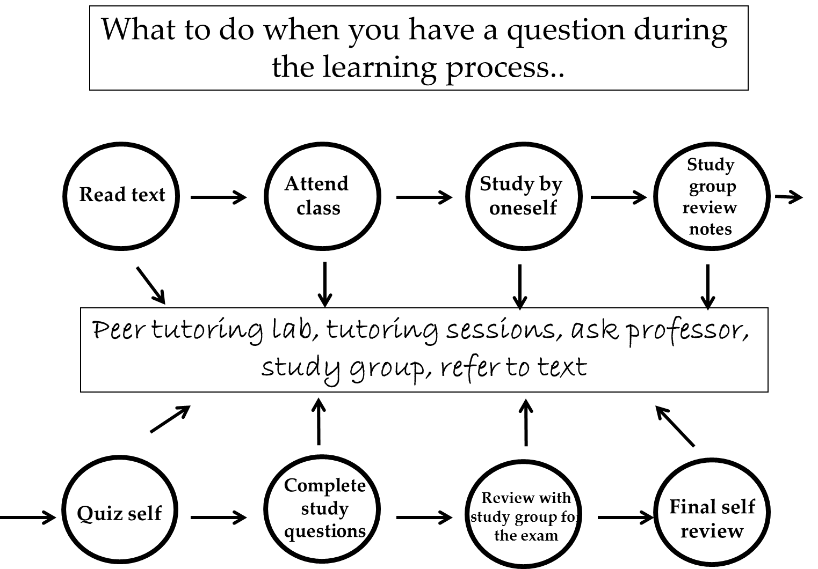

2. After studying Model above, list the activities which will assist you in mastering the material.

1. What do you think the arrows represent?
2. What materials are required for the course? What do assessments require you to use your iclicker software? Which email address should you use to register for Achieve?
3. What are the mandatory prerequisites for the course?
4. List the activities which will be used to calculate your grade.
   1. Which research studies are a part of the course?

6. What is the purpose of the textbook in the class? What is the role of the video lectures?

7. When do the readiness activities need to be completed?

8. Assume for a moment that you are Dr. Ashworth, and this student arrives at your office and asks to take the weekly quiz late because they didn’t come to class. One concern of Dr. Ashworth’s is the need to be fair to all the students in the class taking this weekly quiz. What would you say to this student?

9. Scenario: You opt not to take the weekly quiz because you got off work late. Will you be able to make it up? If so, under which conditions will you be allowed to make it up?

10. Scenario: Erika just completed her weekly quiz. She panicked because she did not perform at the desired level. Is there any reason for her to hope that her quiz score is not as poor as she thinks? Explain.

11. Scenario: Scott just got engaged, and his finance set the date of the wedding on the same day as the final. What would you do to rectify this conflict in light of the policies outline in the Biol 1610 syllabus?

12. When is the homework due?

a. If a person is caught copying homework answers from another student, what will happen?

b. Scenario: Tom gets home from work late, completes homework from other classes, and goes to bed. When he rises the next morning, he realizes he did not complete his biology homework. What options are available to him?

13. Based on the information in the syllabus, what are grades based on?

1. Ethics question: Should grades be changed because a student needs to be accepted to their professional program or because a student begs Dr. Ashworth to change his/her grade?

14. What is the time frame you can expect an email response? What about on the weekends?

15. Who is required to enroll in the Bio 1615 lab?

Please see the next page.

From Claudia Jorgensen, Ph.D., associate professor, Psychology & Counseling Department, Utah Valley University, [cjorgensen@uvu.edu](mailto:cjorgensen@uvu.edu).

**II. POGIL Portion**

**Model 1: Classroom Atmosphere**

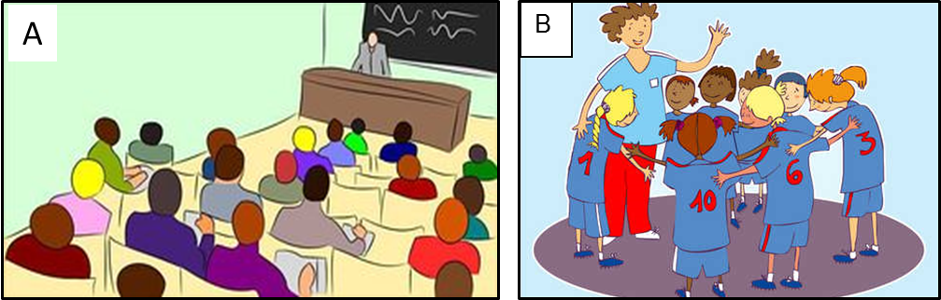

|  |  |
| --- | --- |
| 15A. Describe what kind of situation you see in **image A**. | 15B. Describe what kind of situation you see in **image B**. |
| 16A. Who is the person standing at the very front of the room? | 16B. Who is the tall person standing at the left of the circle? |
| 17A. Who are the people sitting? | 17B. Who are the shorter people circling around? |

1. Compare and contrast the teaching style of a professor and a coach.

|  |  |
| --- | --- |
| **Similarities** | **Differences** |
|  |  |

From Claudia Jorgensen, Ph.D., associate professor, Psychology & Counseling Department, Utah Valley University, [cjorgensen@uvu.edu](mailto:cjorgensen@uvu.edu).

1. Compare and contrast how classmates and team members (e.g., of a soccer team) learn.

|  |  |
| --- | --- |
| **Similarities** | **Differences** |
|  |  |

1. If we want our classroom to mimic the interactions between soccer players and their coaches (rather than the professor-student interactions of most classrooms),
2. What would you call the course instructor?
3. What would you expect class time to look like?
4. What would you expect interactions between the instructor and students to look like?
5. What would you expect student-to-student interactions to look like?

**Please see the next page.**

From Claudia Jorgensen, Ph.D., associate professor, Psychology & Counseling Department, Utah Valley University, [cjorgensen@uvu.edu](mailto:cjorgensen@uvu.edu).

****Read this!

This self-reflection on grades is posted on the syllabus.

**Critical Thinking Questions**

1. Based on this self-reflection, how much effort is necessary to receive a C?

*Answer:*

1. How much effort is necessary to receive a B?

*Answer:*

1. How much effort is necessary to receive an A?

*Answer:*

1. Do you think students who prepare for the assessments in this course using cramming and procrastination are likely to earn a B on these assessments?

*Answer:*

1. What kind of approach should a student take to accomplish an A on the assessments?

*Answer:*

1. Why do you think this self-reflection chart was posted on the syllabus worksheet?

*Answer:*